

Travel Booking Data Analysis using Microsoft Excel and Power BI

CSS7000 INTERNSHIP REPORT

Submitted by

Falak Munir Ahmed Tanga – 20241CSD0098

Under the guidance of,
Ms.Sandhya L

BACHELOR OF TECHNOLOGY

IN

COMPUTER SCIENCE AND ENGINEERING (Data Science)


PRESIDENCY UNIVERSITY
BENGALURU
AUGUST 2026



PRESIDENCY SCHOOL OF
ARTIFICIAL INTELLIGENCE & ADVANCED COMPUTING
BONAFIDE CERTIFICATE

Certified that this report “Travel Booking Data Analysis using Microsoft Excel and Power BI” is a bonafide work of Falak Munir Ahmed Tanga (20241CSD0098), who has successfully carried out the internship work and submitted the report for partial fulfilment of the requirements for the award of the degree of BACHELOR OF TECHNOLOGY in PRESIDENCY SCHOOL OF ARTIFICIAL INTELLIGENCE & ADVANCED COMPUTING, DATA SCIENCE during 2026-2027.

Ms. Sandhya L  Assistant Professor  Internship Guide  PSAIAC  Presidency University | Ms .Sai Dhivya Sarvanakumar  Assistant Professor  Program Internship Coordinator  PSAIAC  Presidency University | Dr. Geetha Arjunan  Associate Professor  School Internship Coordinator  PSAIAC  Presidency University

Dr. S Pravinthraja  Professor & Head of the Department  PSAIAC  Presidency University | Dr. Shakkeera L  Dean  PSAIAC  Presidency University

Sl.No | Name of the Examiner | Signature
1. | Ms. Thabassum Khan



PRESIDENCY UNIVERSITY

PRESIDENCY SCHOOL OF
ARTIFICIAL INTELLIGENCE & ADVANCED COMPUTING
DECLARATION

I am a student of third year B.Tech in COMPUTER SCIENCE AND ENGINEERING (Data Science), at Presidency University, Bengaluru, named Falak Munir Ahmed Tanga, hereby declare that the internship work titled “Travel Booking Data Analysis using Microsoft Excel and Power BI” has been independently carried out by me and submitted in partial fulfillment for the award of the degree of B.Tech in COMPUTER SCIENCE AND ENGINEERING during the academic year of 2026-2027. Further, the matter embodied in the internship has not been submitted previously by anybody for the award of any Degree or Diploma to any other institution.

Falak Munir Ahmed Tanga USN:20241CSD0098 Signature

PLACE: BENGALURU
DATE:
INTERNSHIP COMPLETION CERTIFICATE

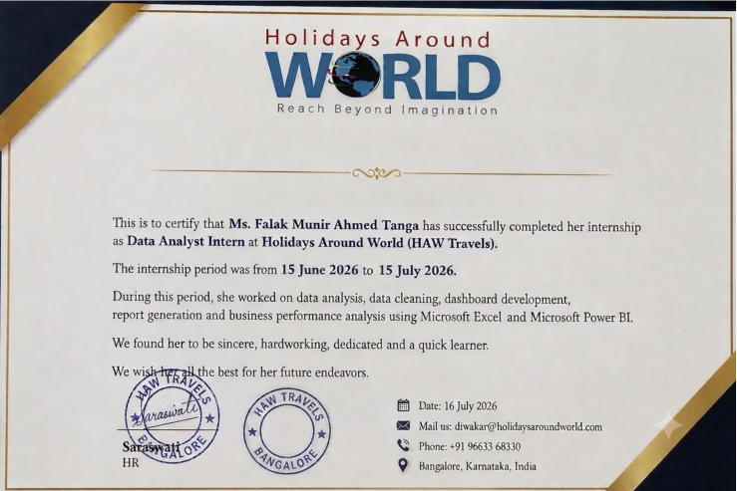

TABLE OF CONTENTS
CHAPTER NO | TITLE | PAGE NO
 | ACKNOWLEDGEMENT | iv
 | ABSTRACT | v
 | TABLE OF CONTENTS | vi
 | LIST OF FIGURES | vii
 | LIST OF TABLES | viii
1. | INTRODUCTION  1.1 BACKGROUND AND MOTIVATION  1.2SCOPE AND LIMITATIONS  1.3 PROBLEM STATEMENT  1.4 MOTIVATION | ix  ix  ix  x  x
2. | About Company or Organization  2.1 Company Overview  2.2 Business Model  2.3 Organizational Structure | xi  x  xi
3. | Working domain or the technology  3.1 Tools and technology used  3.2 Destination-wise Booking and Revenue Analysis  3.3 Cancellation Analysis  3.4 Customer Demographic Analysis  3.5 Monthly Revenue Trend Analysis  3.6 Revenue contribution by Gender and Age Group  3.7 Monthly Revenue trend analysis  3.8 Consolidated Excel Dashboard  3.9 Destination-wise cancellation Analysis  3.10 Destination-wise revenue analysis (pivot)  3.11 Average package cost and customer segmentation  3.12 Revenue contribution and top value bookings  3.13 Destination performance Ranking | xii  xii  xii  xiii  xiii  xiv  xv  xvi  xvii  xviii  xix  xix  xxi  xxii
4. | About your team and reporting Manager  4.1 Team Structure  4.2 Reporting Manager  4.3 Dashboard Development---Components and architecture  4.3.1 Data import and KPI cards  4.3.2 Core Visuals  4.3.3 Customer segmentation and booking visual  4.3.4 Formatting and visual design  4.3.5 Dynamic KPI cards using DAX measure  4.3.6 Interactivity and final formatting  4.3.7 Validation and final dashboard  4.3.8 Business recommendation panel  4.4 Description of components  4.5 Summary | xxiv  xxiv  xxiv  xxiv  xxiv  xxv  xxv  xxvi  xxvii  xxviii  xxix  xxxii  xxxiii  xxxiii
5 | Challenges Faced in Internship  5.1 Data related challenges  5.2 Learning DAX  5.3 Dashboard design and usability  5.4 Interpreting Business Implication  5.5 Time management | xxxiv  xxxiv  xxxiv  xxxiv  xxxiv  xxxv
6. | Objectives of the work | xxxvii
7 | Github Link  Conclusion | xxxviii  xxxviii
8 | REFERENCES | xxxix

ACKNOWLEDGEMENT

For completing this internship work, I have received the support and the guidance from many people whom I would like to mention with deep sense of gratitude and indebtedness. I extend my gratitude to our beloved Chancellor, Pro-Vice Chancellor, and Registrar for their support and encouragement in completion of the internship.
I would like to sincerely thank my internal guide Ms.Sandhya L, Assistant Professor Presidency School Of Artificial Intelligence & Advanced Computing Presidency University, for her moral support, motivation, timely guidance and encouragement provided to me during the period of internship work.
I am also thankful to Dr. S Pravinthraja , Professor, Head of the Department, Presidency School of Artificial Intelligence & Advanced Computing, Presidency University, for his mentorship and encouragement.
I express my cordial thanks to Dr. Shakkeera L, Dean, Presidency School Of Artificial Intelligence & Advanced Computing, Presidency University for providing the required facilities and intellectually stimulating environment that aided in the completion of my internship work.
We are grateful to Dr. Geetha Arjunan, Associate Professor, School Internship Coordinator, Ms. Sai Dhivya Sarvanakumar, Assistant Professor, Program Internship Coordinator, Presidency School of Artificial Intelligence & Advanced Computing, Presidency University for facilitating problem statements, coordinating reviews, monitoring progress, and providing their valuable support and guidance.
I am also grateful to Teaching and Non-Teaching staff of Presidency School of Artificial Intelligence & Advanced Computing and also staff from other departments who have extended their valuable help and cooperation.
Falak Munir Ahmed Tanga

ABSTRACT

Internships provide students with an opportunity to bridge the gap between academic learning and real-world industrial practices by applying theoretical knowledge to practical business problems. As part of the Bachelor of Technology curriculum in Computer Science and Engineering (Data Science), I completed a one-month internship at Holidays Around World (HAW Travels) as a Data Analyst Intern from 15 June 2026 to 15 July 2026. The internship was focused on analyzing travel booking data and developing interactive business intelligence dashboards to support data-driven decision-making within the organization.
The primary objective of the internship was to understand the process of collecting, cleaning, organizing, analyzing, and visualizing business data using modern analytical tools. Microsoft Excel was extensively used for data cleaning, preprocessing, validation, and the creation of Pivot Tables and Pivot Charts. The cleaned dataset was then imported into Microsoft Power BI to design an interactive dashboard that provides meaningful insights into the company's travel booking performance.
Several Key Performance Indicators (KPIs) were developed to evaluate overall business performance, including Total Bookings, Total Revenue, Confirmed Bookings, Cancelled Bookings, Average Package Cost, and Cancellation Rate. In addition, DAX (Data Analysis Expressions) measures were created to perform business calculations and generate dynamic metrics. Various interactive visualizations were designed to analyze destination-wise revenue, monthly booking trends, customer segmentation, revenue by age group, gender-wise revenue distribution, and booking status across different travel destinations. Slicers were also incorporated to enable users to filter the dashboard dynamically based on destination, month, and gender.
The dashboard provides a comprehensive overview of the organization's business performance and highlights valuable trends that can support strategic decision-making. The analysis revealed variations in revenue across travel destinations, differences in customer segments, booking patterns over time, and destination-specific cancellation rates. These insights can assist the management in identifying profitable destinations, understanding customer preferences, optimizing marketing strategies, and improving operational efficiency.
This internship significantly enhanced my practical understanding of data analytics, business intelligence, and data visualization. It strengthened my technical skills in Microsoft Excel, Microsoft Power BI, DAX, and dashboard development while improving my analytical thinking, problem-solving abilities, and report preparation skills. The experience also provided valuable exposure to handling real-world business data and demonstrated how data-driven insights contribute to organizational growth and effective decision-making. Overall, the internship served as an excellent platform for applying academic knowledge in a professional environment and gaining industry-relevant experience in the field of data analytics.

LIST OF FIGURES

Figure 1: PivotTable showing destination-wise booking counts.
Figure 2: PivotTable/chart of destination-wise revenue analysis.
Figure 3: PivotTable/summary of overall cancellation analysis.
Figure 4: Bookings by customer age group.
Figure 5: Bookings by customer gender.
Figure 6: Monthly booking trend (summary view).
Figure 7: Monthly booking trend chart, January–June 2026.
Figure 8: Revenue contribution by gender.
Figure 9: Revenue contribution by age group.
Figure 10: Monthly revenue trend, January–June 2026.
Figure 11: Consolidated interactive Excel dashboard with KPI cards and slicers.
Figure 12: Destination-wise cancellation rate comparison.
Figure 13: Destination-wise revenue pivot analysis.
Figure 14: Average package cost by destination.
Figure 15: Customer segmentation by spending tier (Budget / Standard / Premium).
Figure 16: Summary table of customer segment revenue contribution.
Figure 17: Percentage revenue contribution by destination.
Figure 18: Revenue distribution pie chart by destination.
Figure 19: Overall destination performance ranking chart.
Figure 20: Initial Power BI dashboard with KPI cards and core visuals.
Figure 21: Enhanced dashboard with customer-segment donut chart and booking-status visual.
Figure 22: Formatted dashboard with applied theme, title and Key Business Insights panel.
Figure 23: Dynamic KPI cards driven by DAX measures, responsive to slicer selections.
Figure 24: Dashboard with tooltip interactivity and finalised formatting.
Figure 25: Final, validated HAW Performance Dashboard.
Figure 26: Final dashboard — alternate filtered view.
Figure 27: Final dashboard — alternate filtered view.
Figure 28: Final dashboard including the Business Recommendations panel.

LIST OF TABLES

Table 1: Destination-wise booking counts and revenue summary.
Table 2: Overall booking status summary (Confirmed vs Cancelled).
Table 3: Customer segmentation summary (Budget / Standard / Premium).
Table 4: Destination-wise cancellation rate summary.
Table 5: Average package cost by destination.

1. INTRODUCTION

1.1 Background and Motivation
The tourism and travel industry generates enormous volumes of transactional data every day bookings, cancellations, customer profiles, destination preferences and payment records. For a travel agency such as Holidays Around World (HAW Travels), this data holds the key to understanding which destinations are performing well, which customer segments are most valuable, and where the business is losing revenue through cancellations. However, in many small and mid-sized travel businesses this data remains locked inside spreadsheets and booking systems, rarely converted into a form that management can use to make decisions.
This internship was undertaken to address that gap by applying data analysis and business intelligence techniques to a real travel-booking dataset. The work combined Microsoft Excel, for exploratory analysis using pivot tables and charts, with Microsoft Power BI, for building an interactive, decision-support dashboard. The motivation for choosing this domain was twofold: first, the travel and tourism sector is data-rich but frequently under-analysed, offering a meaningful real-world problem; and second, the combination of Excel and Power BI represents one of the most widely used business-analytics toolchains in the industry, making the internship directly relevant to a career in data analytics and business intelligence.
Over the course of the internship, the work moved from simple descriptive statistics counting bookings per destination, computing revenue totals to more advanced analysis involving customer segmentation, cancellation-rate modelling, and finally to the design of a fully interactive Power BI dashboard driven by DAX (Data Analysis Expressions) measures. This progression mirrors the typical lifecycle of a business-intelligence project in industry: data preparation, exploratory analysis, insight generation, and dashboard/report delivery.

1.2 Scope and Limitations
The scope of this internship was limited to the analysis of a single structured dataset of 200 travel bookings covering six destinations (Dubai, Bali, Kashmir, Manali, Goa and Kerala) over a six-month booking period (January–June 2026). The work covered:
- Data cleaning and preparation of the raw booking dataset.
- Exploratory analysis in Microsoft Excel using pivot tables, pivot charts and formulas.
- Destination-wise, revenue-wise, cancellation-wise, age-group-wise and gender-wise analysis.
- Customer segmentation based on package spending (Budget, Standard, Premium).
- Design and development of an interactive Power BI dashboard with KPI cards, slicers and DAX measures.
- Formulation of business recommendations based on the analytical findings.
The internship did not extend to live integration with HAW Travels’ production booking system, predictive modelling or machine-learning based forecasting, or automated data pipelines. The analysis was performed on a static, exported dataset rather than a live data feed, and the dashboard was built and validated within Power BI Desktop rather than deployed to the Power BI Service. These represent natural extensions of the work that were outside the time and scope available during the internship.

1.3 Problem Statement
Holidays Around World (HAW Travels) had accumulated six months of booking data across multiple destinations but lacked a structured, visual way to understand booking trends, revenue drivers, customer demographics and the causes of lost revenue through cancellations. Management decisions on marketing spend, destination promotion and pricing were being made without a consolidated, data-driven view of business performance. The problem addressed by this internship was: how can the available booking data be analysed and visualised to give management a clear, interactive and reliable picture of business performance covering bookings, revenue, customer segments and cancellations that supports faster and better-informed decision-making?

1.4 Motivation
Beyond the organisational motivation described above, the internship offered a strong personal learning motivation: to build hands-on proficiency with the analytics tools most in demand in the data-analyst job market Excel pivot tables, Power BI report design, and DAX measure authoring while working on an authentic business problem rather than a synthetic classroom exercise. Translating raw numbers into a dashboard that a non-technical business owner could use directly required attention not only to analytical correctness but also to visual design, usability and communication skills that are central to the role of a data/business analyst.

2. ABOUT COMPANY OR ORGANIZATION

2.1 Company Overview
Holidays Around World (HAW Travels) is a travel booking agency that curates and sells holiday packages across a portfolio of popular domestic and international destinations, including Dubai, Bali, Kashmir, Manali, Goa and Kerala. The company operates as an intermediary between travelers and destination service providers hotels, local transport operators and activity vendors assembling these components into bundled packages that are sold directly to customers through its booking channels.
HAW Travels serves a broad customer base spanning budget-conscious travelers seeking affordable domestic getaways to premium customers booking high-value international holidays such as Bali and Dubai packages. The company’s package pricing spans from economical domestic offerings (Goa and Manali, averaging around ₹18,000–₹20,000 per booking) to premium international packages (Bali and Dubai, averaging ₹60,000–₹70,000 per booking), reflecting a deliberately tiered product strategy aimed at capturing multiple customer segments.

2.2 Business Model
The organisation’s core business model is built around package-based travel sales: customers select a destination and a bundled package (accommodation, and in many cases transport and activities), pay a package cost, and the booking is tracked through its lifecycle from Confirmed to, in some cases, Cancelled. Revenue is recognised primarily on confirmed bookings, and cancellations represent both a direct loss of expected revenue and, indirectly, an inefficiency in marketing and customer-acquisition spend.
Because the company’s revenue is concentrated in a small number of flagship destinations, understanding the relative contribution and risk profile (cancellation rate) of each destination is commercially important this is precisely the analytical gap that this internship was designed to fill.

2.3 Organisational Structure
HAW Travels maintains a lean operating structure typical of a mid-sized travel agency, with functional groups responsible for sales and bookings, destination and vendor partnerships, customer support, and business operations/reporting. The internship was hosted within the business operations and reporting function, which is responsible for consolidating booking data, tracking key performance indicators and supporting management decision-making the natural home for a data-analysis and dashboarding project of this kind.

3. WORKING DOMAIN OR THE TECHNOLOGY
The internship was carried out in the domain of Business Intelligence (BI) and Data Analytics, applied to the travel and tourism sector. Two principal technologies were used throughout the internship: Microsoft Excel, for data cleaning, exploratory analysis and pivot-table-based reporting; and Microsoft Power BI, for building an interactive, DAX-driven business dashboard. This chapter documents the technical work carried out, organised chronologically as the analysis progressed.

3.1 Tools and Technologies Used
- Microsoft Excel – PivotTables, Pivot Charts, formulas, and conditional formatting for exploratory data analysis.
- Microsoft Power BI Desktop – data modelling, report design, and DAX measures for the interactive dashboard.
- DAX (Data Analysis Expressions) – for dynamic, filter-aware KPI calculations.
- The underlying dataset: a Travel Bookings table of 200 records with fields including Booking_ID, Customer_Name, Age, Gender, Destination, Package_Cost, Booking_Date and Status.

3.2 Destination-wise Booking and Revenue Analysis
The first stage of the analysis used Excel PivotTables to summarise booking counts by destination. Dubai received the highest number of bookings (41), followed by Manali (36), Kashmir (35), Goa (33), Bali (32) and Kerala, which recorded the lowest volume with 23 bookings out of a total of 200. A parallel revenue analysis showed that Dubai generated the highest total revenue at ₹24,93,352, with Bali close behind at ₹22,51,676; Kerala again ranked lowest, generating just ₹5,16,974.
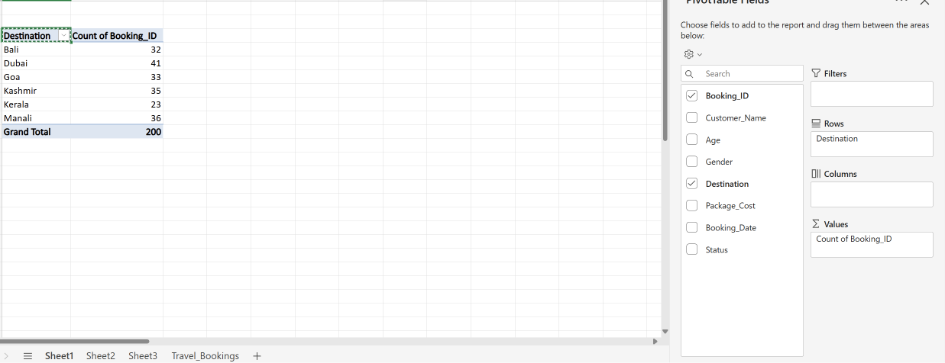
Figure 1: PivotTable showing destination-wise booking counts.
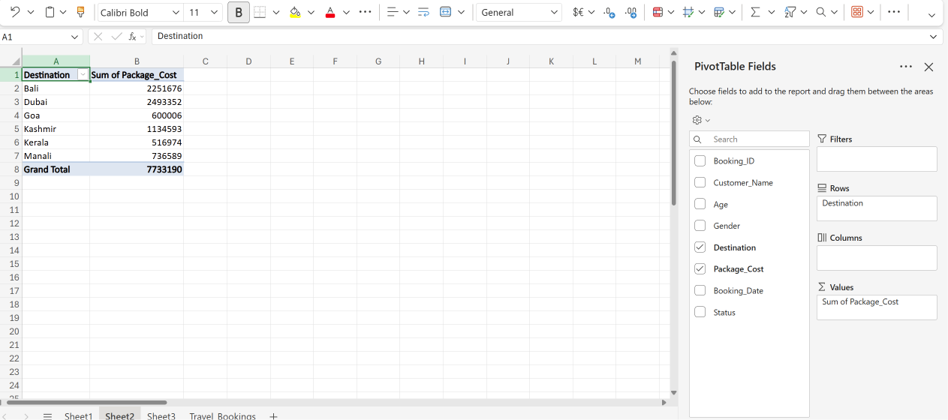
Figure 2: PivotTable/chart of destination-wise revenue analysis.

3.3 Cancellation Analysis
Of the 200 total bookings, 155 were Confirmed and 45 were Cancelled, giving an overall cancellation rate of 22.5% (45 ÷ 200 × 100). This baseline cancellation figure became an important reference point for the destination-wise cancellation study carried out later in the internship. The business conclusion at this stage was that while Dubai was the strongest destination by both bookings and revenue, the underlying causes of the 22.5% cancellation rate needed further investigation before marketing spend could be safely increased.
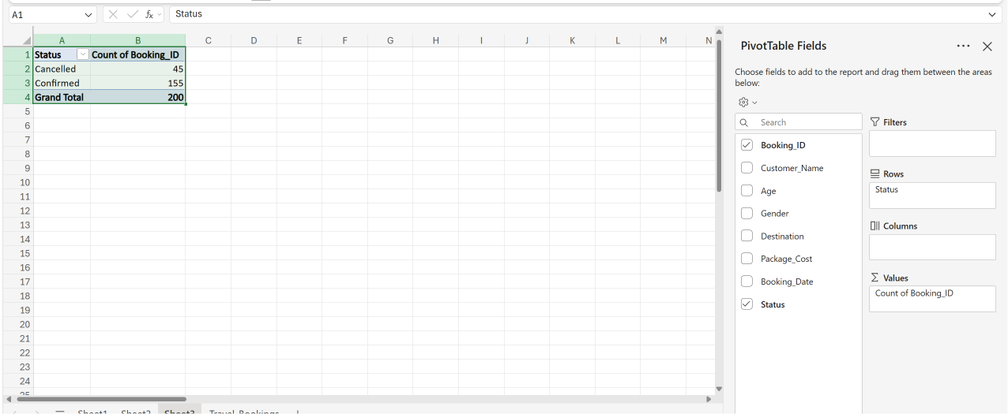
Figure 3: PivotTable/summary of overall cancellation analysis.

3.4 Customer Demographic Analysis
An age-group analysis was performed to understand the demographic profile of HAW Travels’ customers. The 36–40 age group recorded the highest number of bookings (42), followed closely by the 21–25 age group (41). The 31–35 and 41–45 age groups each contributed 33 bookings, while the 26–30 and 46–50 age groups recorded 26 and 25 bookings respectively. This indicated that working professionals and middle-aged customers form a significant share of the customer base, an insight that can guide targeted marketing and customised package design.
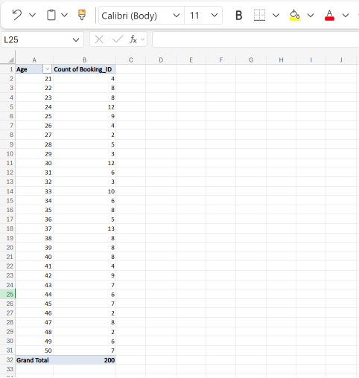
Figure 4: Bookings by customer age group.
A gender-wise analysis showed a relatively balanced customer base: male customers accounted for 107 bookings (53.5%) and female customers for 93 bookings (46.5%), suggesting an opportunity to grow engagement among female travellers through targeted promotions.
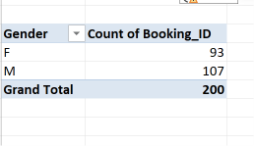
Figure 5: Bookings by customer gender.

3.5 Monthly Booking Trend Analysis
Booking patterns were analysed from January to June 2026 to identify seasonal demand trends. January recorded the highest booking volume (38), followed by April (36) and February (34); May and June recorded 32 and 31 bookings respectively, while March recorded the lowest volume (29). The booking pattern remained relatively stable across the six-month period, which helps the organisation plan promotional campaigns and allocate resources more effectively.
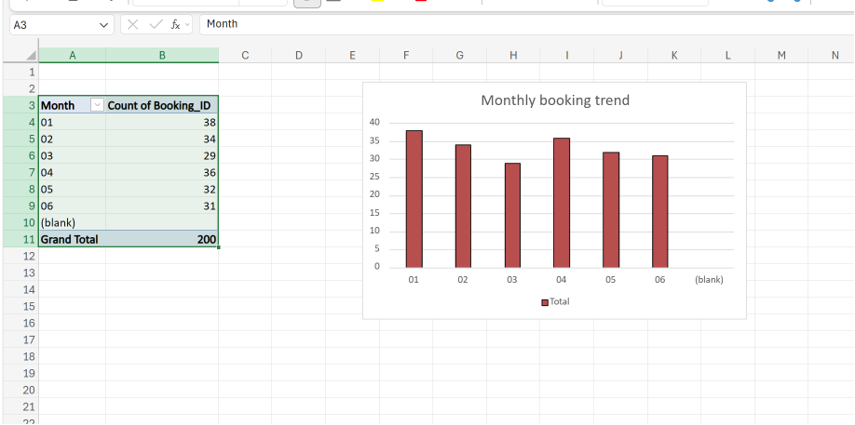
Figure 6: Monthly booking trend (summary view).

Figure 7: Monthly booking trend chart, January–June 2026.

3.6 Revenue Contribution by Gender and Age Group
A gender-wise revenue analysis found that male customers generated ₹40,74,446 (approximately 52.7% of total revenue) while female customers generated ₹36,58,744 (47.3%), indicating that HAW Travels’ packages appeal in a fairly balanced way across both customer groups.
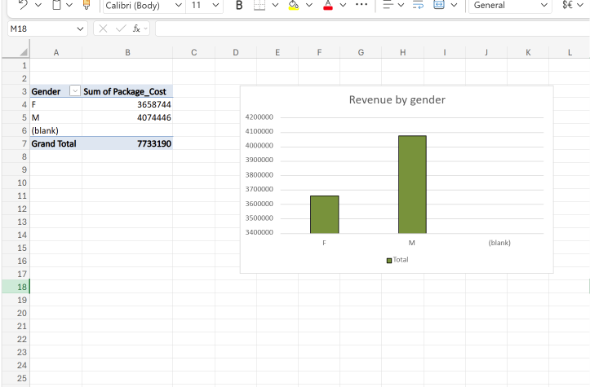
Figure 8: Revenue contribution by gender.
An age-group revenue analysis showed the 36–40 age group generating the highest revenue (₹17,18,534), followed by the 21–25 age group (₹16,99,426) and the 31–35 age group (₹14,05,968). This confirmed that middle-aged, working professional customers are not only the largest booking segment but also the most valuable in revenue terms.
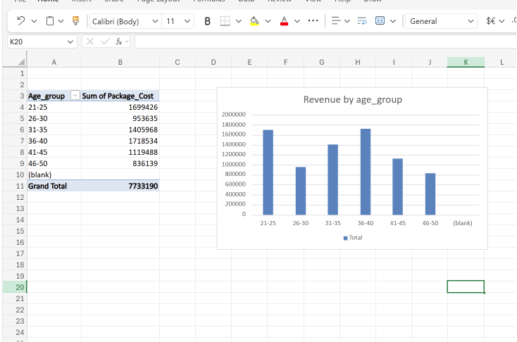
Figure 9: Revenue contribution by age group.

3.7 Monthly Revenue Trend Analysis
Monthly revenue analysis showed February generating the highest revenue (₹15,29,782), ahead of January (₹14,77,289) and April (₹14,26,755). June generated ₹11,72,695, May ₹10,91,475, and March recorded the lowest revenue at ₹10,35,194. The total revenue analysed across the six-month period was ₹77,33,190. The higher revenue recorded in February — despite January having the highest booking count — suggested that February bookings skewed towards higher-value packages.
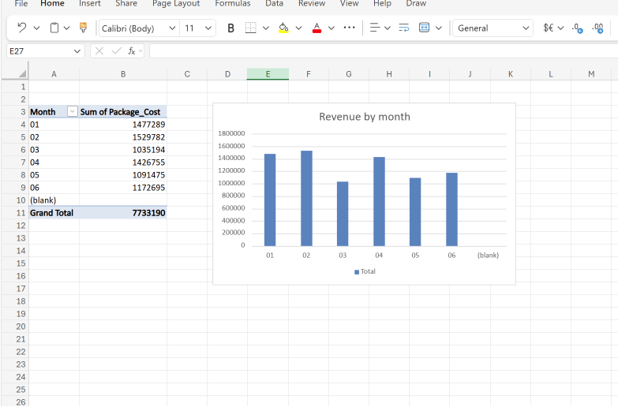
Figure 10: Monthly revenue trend, January–June 2026.

3.8 Consolidated Excel Dashboard
Once the individual analyses were complete, an interactive Excel dashboard was developed to bring booking, revenue, demographic and cancellation analysis into a single reporting interface, with KPI summaries for Total Bookings, Total Revenue, Cancellation Rate, Top Destination and Best Revenue Month, supported by slicers for Destination, Month and Gender.
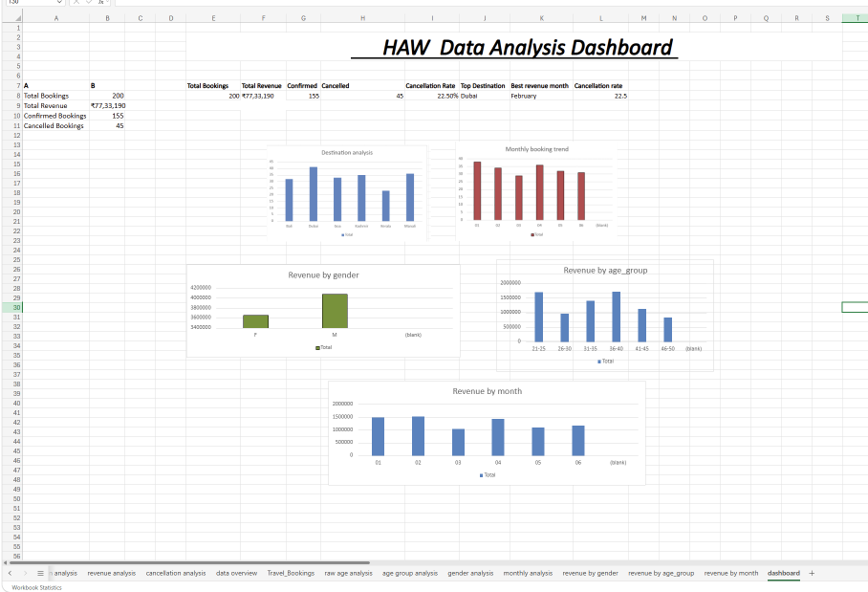
Figure 11: Consolidated interactive Excel dashboard with KPI cards and slicers.

3.9 Destination-wise Cancellation Analysis
A focused destination-wise cancellation study was carried out to identify which destinations posed the greatest cancellation risk. Dubai recorded the highest cancellation rate at 36.59%, followed by Kerala at 34.78%. Manali recorded a cancellation rate of 22.22%, while Bali (15.63%) and Kashmir (14.29%) performed considerably better. Goa recorded the lowest cancellation rate of all destinations at 12.12%. This finding was significant: Dubai, despite being the top revenue generator, also carried the highest cancellation risk, while Goa — a comparatively low-revenue destination — showed the strongest booking retention.
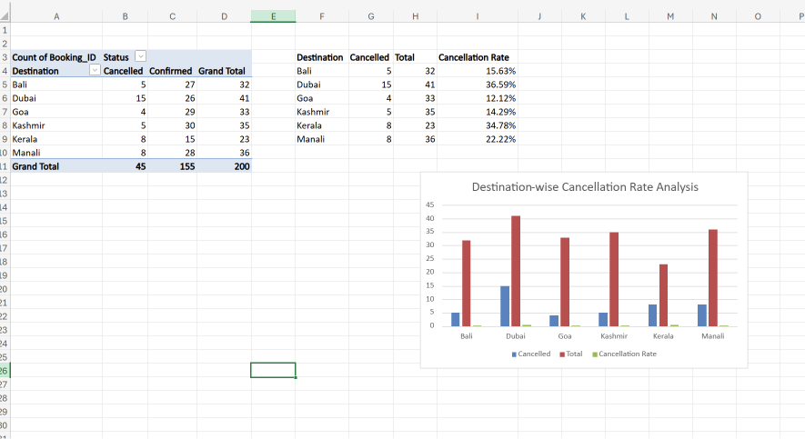
Figure 12: Destination-wise cancellation rate comparison.

3.10 Destination-wise Revenue Analysis (Pivot-based)
A dedicated revenue pivot table confirmed Dubai as the top revenue generator (₹24,93,352), with Bali second (₹22,51,676), followed by Kashmir (₹11,34,593), Manali (₹7,36,589), Goa (₹6,00,006) and Kerala, which generated the lowest revenue (₹5,16,974).
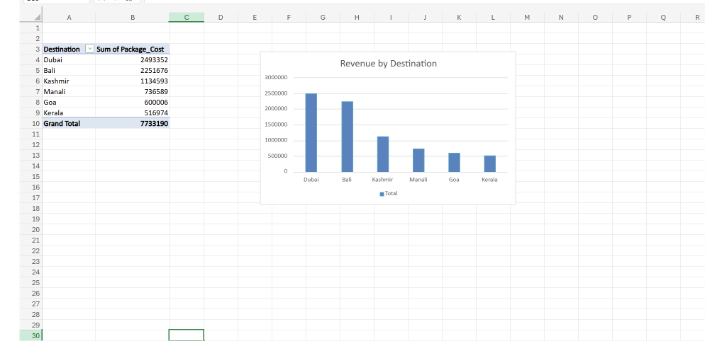
Figure 13: Destination-wise revenue pivot analysis.

3.11 Average Package Cost and Customer Segmentation
An average-package-cost analysis classified destinations into pricing tiers: Bali recorded the highest average package cost (₹70,364.88), followed by Dubai (₹60,813.46); Kashmir sat in a mid-range tier (₹32,416.94), while Kerala, Manali and Goa formed the budget tier, with Goa the lowest at ₹18,182.00.
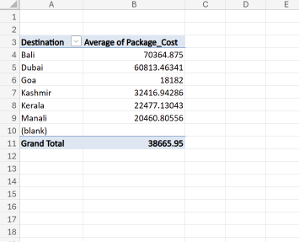
Figure 14: Average package cost by destination.
Using package cost as the basis, customers were segmented into Budget, Standard and Premium tiers. Budget customers made up 52% of bookings (104), Premium customers 36.5% (73) and Standard customers 11.5% (23). Despite being the smallest group by count, Premium customers generated the highest revenue (₹47,45,028, about 61.4% of total revenue), while Budget customers generated ₹21,84,244 and Standard customers ₹8,03,918.
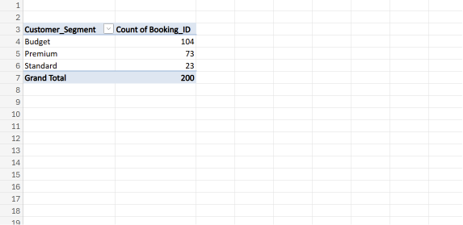
Figure 15: Customer segmentation by spending tier (Budget / Standard / Premium).
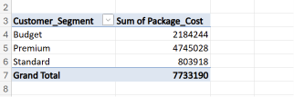
Figure 16: Summary table of customer segment revenue contribution.

3.12 Revenue Contribution and Top-Value Bookings
A revenue-share analysis showed Dubai contributing the largest single share of total revenue at 32%, with Bali at 29%; together these two destinations accounted for 61% of all revenue. Kashmir contributed 15%, Manali 10%, and Goa and Kerala 8% and 7% respectively.
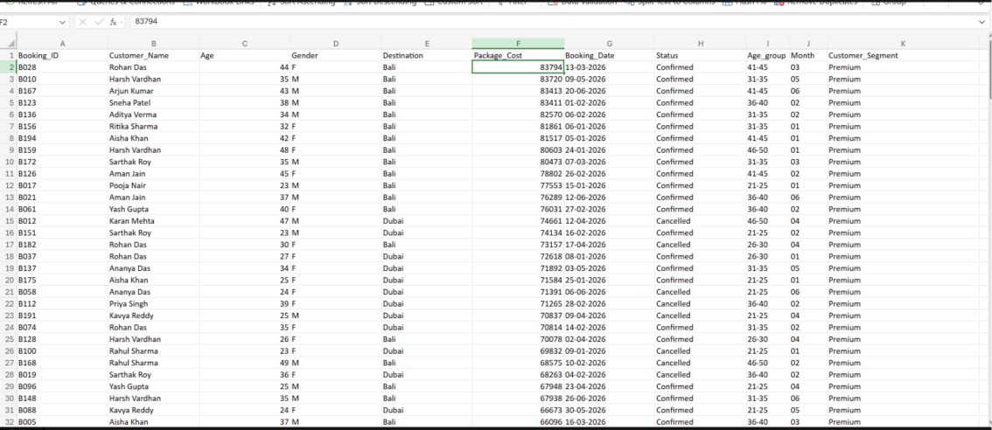
Figure 17: Percentage revenue contribution by destination.
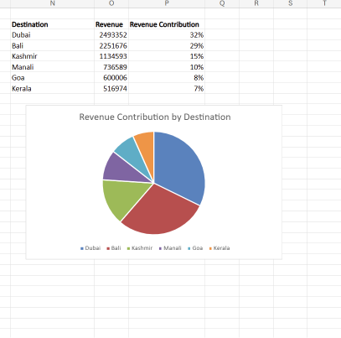
Figure 18: Revenue distribution pie chart by destination.
A top-value booking analysis, sorting all 200 bookings by package cost in descending order, found that the highest single booking value was ₹83,794, and that all of the top 10 highest-value bookings belonged to Bali — confirming Bali’s position as HAW Travels’ premium destination of choice.

3.13 Destination Performance Ranking
Combining booking volume, revenue and cancellation-rate data produced an overall destination performance ranking: Bali was ranked Excellent (strong revenue, low cancellations); Kashmir Very Good; Goa Good (lowest cancellation rate of all); Dubai was classified as High Revenue, High Risk owing to its high cancellation rate; Manali was rated Average; and Kerala was flagged as Needs Improvement, combining the lowest revenue with one of the highest cancellation rates.
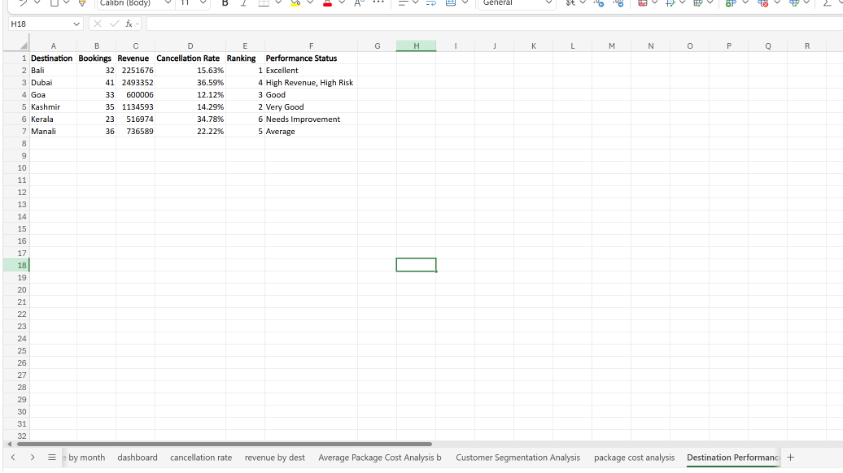
Figure 19: Overall destination performance ranking chart.

4. ABOUT YOUR TEAM AND REPORTING MANAGER

4.1 Team Structure
The internship was carried out largely as an individually-owned analytics project, supported by a small internal reporting team at HAW Travels responsible for consolidating booking data from the company’s reservation records. Progress was reviewed periodically with the reporting manager, who provided the business context needed to interpret the data correctly for example, confirming which package-cost ranges should be treated as Budget, Standard and Premium, and clarifying how cancellations were recorded in the source system.

4.2 Reporting Manager
The reporting manager for the internship oversaw the business-operations and reporting function at HAW Travels and was the primary point of contact for validating analytical findings, prioritising which KPIs mattered most to management, and reviewing the dashboard at each stage of development. Weekly check-ins ensured that the analysis remained aligned with genuine business questions rather than becoming a purely technical exercise.

4.3 Dashboard Development -- Components and Architecture
Following the completion of the Excel-based exploratory analysis described in Chapter 3, the internship moved into building a Power BI dashboard — referred to internally as the HAW Performance Dashboard. This section documents the components of that dashboard in the order they were developed.

4.3.1 Data Import and KPI Cards
The Travel Booking dataset was imported into Power BI Desktop, and the first set of components built were KPI cards displaying Total Bookings (200), Total Revenue (₹7,733,190), Confirmed Bookings (155) and Cancelled Bookings (45). These cards form the top-level summary strip of the dashboard, giving an at-a-glance view of overall business scale and health.
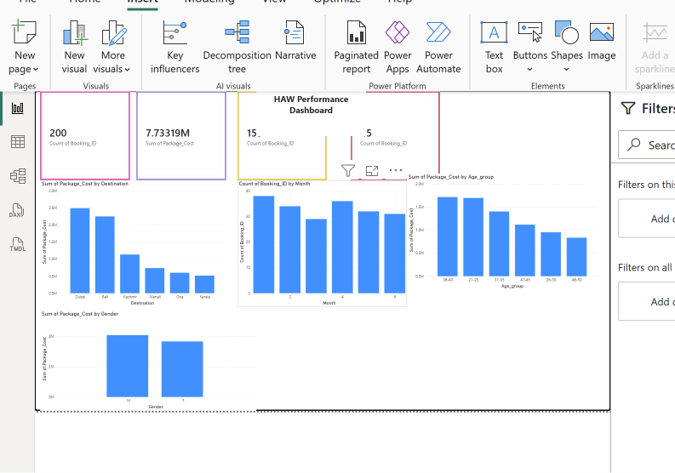
Figure 20: Initial Power BI dashboard with KPI cards and core visuals.

4.3.2 Core Visuals
Around the KPI cards, four core visuals were developed: a Revenue by Destination bar chart, a Monthly Booking Trend line chart, a Revenue by Age Group chart, and a Revenue by Gender chart. Together these allowed the reporting manager to move from the headline numbers into the underlying drivers of revenue and booking volume.

4.3.3 Customer Segmentation and Booking-Status Visuals
The dashboard was then extended with a Customer Segment Distribution donut chart (Budget / Standard / Premium), a Revenue by Customer Segment chart, and a Booking Status by Destination chart comparing confirmed and cancelled bookings across destinations. Interactive slicers for Destination, Month and Gender were added at this stage, enabling dynamic, cross-filtered exploration of every visual on the page.
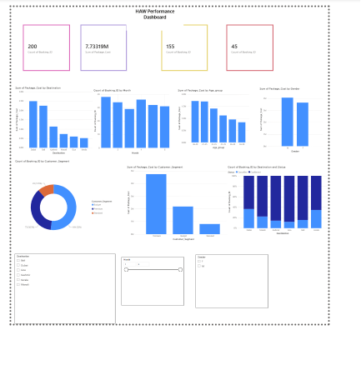
Figure 21: Enhanced dashboard with customer-segment donut chart and booking-status visual.

4.3.4 Formatting and Visual Design
A professional Power BI theme was applied, together with a dashboard title, subtitle, consistent KPI card formatting, and renamed visual titles for readability. A Key Business Insights text panel was added, summarising the major findings directly on the dashboard so that a business user did not need to interpret the charts unaided.
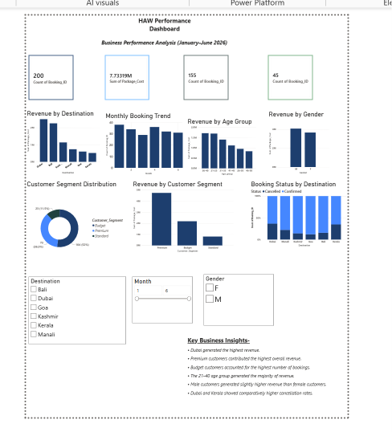
Figure 22: Formatted dashboard with applied theme, title and Key Business Insights panel.

4.3.5 Dynamic KPI Cards Using DAX Measures
Static KPI cards were replaced with dynamic DAX measures for Total Revenue, Total Bookings, Confirmed Bookings, Cancelled Bookings, Cancellation Rate, Average Package Cost, and Average Revenue per Booking. This was the most technically significant component of the dashboard: because these values were now DAX measures rather than hard-coded numbers, every KPI card updated automatically and correctly whenever a user changed the Destination, Month or Gender slicer, rather than showing a fixed, whole-dataset figure.
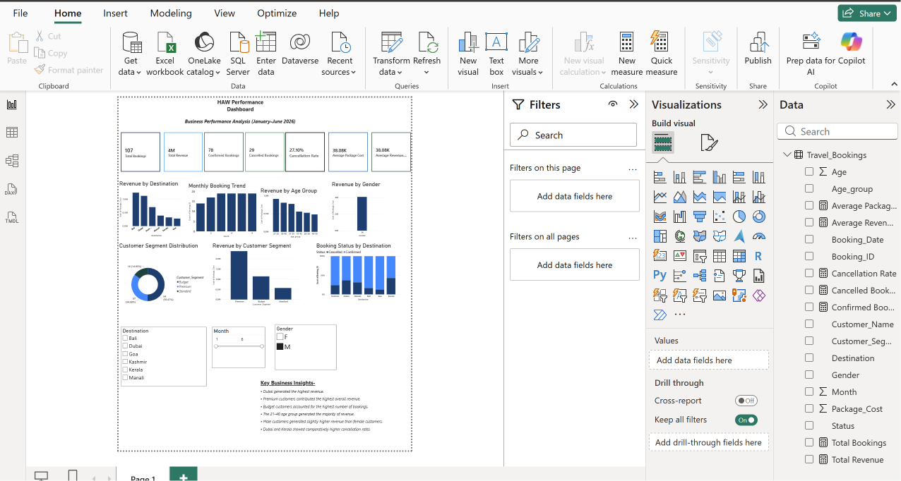
Figure 23: Dynamic KPI cards driven by DAX measures, responsive to slicer selections.

4.3.6 Interactivity and Final Formatting
Tooltip functionality was added to the visuals to surface detailed figures on hover without cluttering the page, chart titles and overall formatting were standardised, and a project footer was added ahead of finalising the dashboard for presentation.
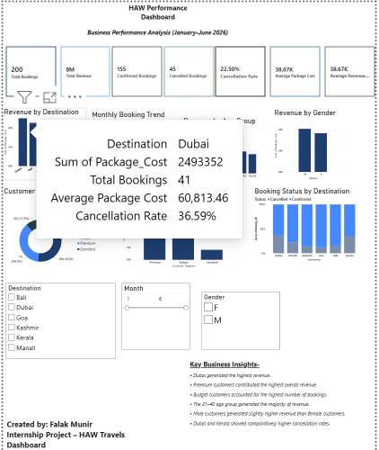
Figure 24: Dashboard with tooltip interactivity and finalised formatting.

4.3.7 Validation and Final Dashboard
All dashboard visuals, KPI cards, charts and slicers were reviewed and tested for accuracy and correct interactive behaviour, and the completed HAW Performance Dashboard was finalised for submission. The finished, single-page dashboard integrates KPI cards, six analytical visuals, three interactive slicers and a business-insights panel into one cohesive view of business performance.
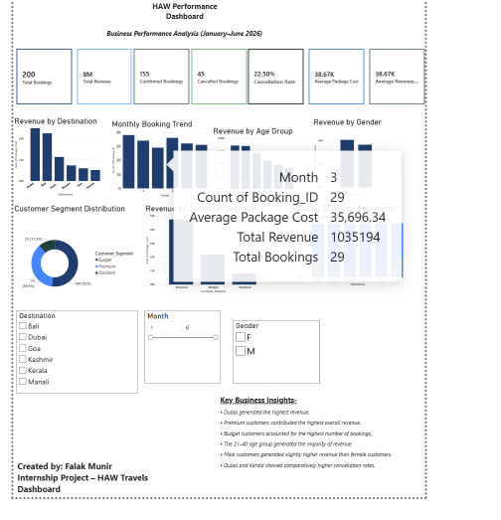
Figure 25: Final, validated HAW Performance Dashboard.
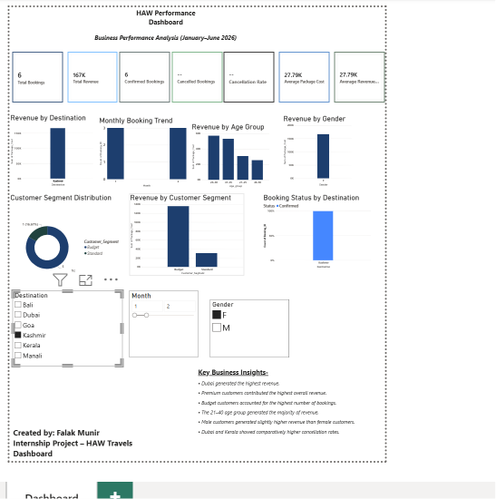
Figure 26: Final dashboard — alternate filtered view.
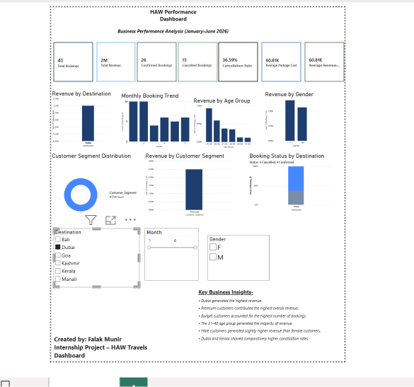
Figure 27: Final dashboard — alternate filtered view.

4.3.8 Business Recommendations Panel
In the closing stage of dashboard development, a Business Recommendations section was added directly to the dashboard, together with project metadata, so that the dashboard combined descriptive analytics with prescriptive, actionable guidance for management in a single artefact.
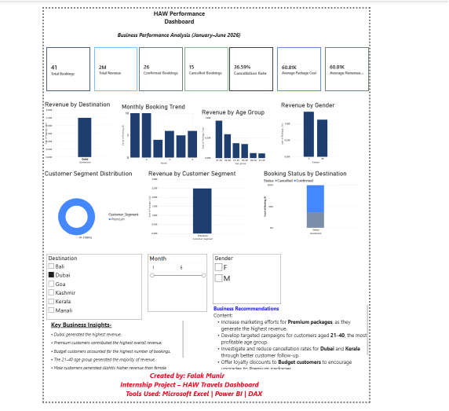
Figure 28: Final dashboard including the Business Recommendations panel.

4.4 Description of Components
In summary, the finished HAW Performance Dashboard is composed of the following components: (i) a KPI strip of dynamic DAX-driven cards; (ii) a Revenue by Destination visual; (iii) a Monthly Booking Trend visual; (iv) a Revenue by Age Group visual; (v) a Revenue by Gender visual; (vi) a Customer Segment Distribution donut chart; (vii) a Booking Status by Destination visual; (viii) Destination, Month and Gender slicers; and (ix) Key Business Insights and Business Recommendations text panels. Each component was individually validated against the Excel-based analysis in Chapter 3 to ensure consistency between the two deliverables.

4.5 Summary
This chapter has documented the design and development of the Power BI dashboard component by component, from the initial KPI cards and core visuals through to dynamic DAX measures, interactivity, formatting and the final business-recommendations panel. The dashboard represents the primary technical deliverable of the internship, translating the exploratory Excel analysis of Chapter 3 into a single, interactive tool that HAW Travels’ management can use on an ongoing basis to monitor bookings, revenue, customer segments and cancellation risk.

5. CHALLENGES FACED IN INTERNSHIP

5.1 Data-Related Challenges
The raw booking dataset required careful cleaning before analysis could begin. Ensuring consistent destination naming, correctly typed date and currency fields, and a clean Confirmed/Cancelled status column was a necessary but time-consuming first step, and small inconsistencies in the raw data if left uncorrected would have produced misleading pivot-table totals. Verifying totals (for example, confirming that Confirmed + Cancelled bookings summed to exactly 200) was an important discipline adopted throughout the internship to catch such errors early.

5.2 Learning DAX
The most significant technical challenge was learning to write correct, filter-aware DAX measures. Early versions of KPI cards used static, hard-coded values that did not respond to slicer selections; recognising why this was wrong and rewriting the KPIs as true DAX measures using functions that respect the active filter context required a real shift in understanding, from thinking of Power BI as a static chart tool to thinking of it as a dynamic calculation engine. Getting the Cancellation Rate measure to recalculate correctly for every combination of Destination, Month and Gender slicer, rather than always showing the whole-dataset value, took several iterations of testing.

5.3 Dashboard Design and Usability
Fitting KPI cards, six visuals, three slicers and two text panels onto a single, readable dashboard page without the layout becoming cluttered required several rounds of formatting, resizing and rearrangement. Balancing visual density against readability, and choosing a colour theme and chart types that communicated the findings clearly to a non-technical audience, was an iterative design challenge distinct from the underlying analytical work.

5.4 Interpreting Business Implications
Producing a correct number (such as a 36.59% cancellation rate for Dubai) was only half the task; translating that number into a specific, actionable business recommendation required understanding the commercial context of the travel industry for example, ecognizing that a high-revenue, high-cancellation destination like Dubai needed investigation rather than simply more marketing spend, whereas a low-cancellation destination like Goa could be used as an internal benchmark for customer retention practices.

5.5 Time Management
Balancing the depth of exploratory analysis in Excel against the time available for dashboard development in Power BI required careful planning across the internship period, particularly as later-stage dashboard refinements (formatting, DAX rework, documentation) each took longer than initially estimated.

6. OBJECTIVES OF THE WORK
- To clean and prepare the HAW Travels booking dataset for reliable analysis.
- To perform destination-wise, revenue-wise and cancellation-wise analysis of travel bookings using Microsoft Excel PivotTables and PivotCharts.
- To analyse customer demographics (age group and gender) and their relationship to booking volume and revenue.
- To segment customers by spending tier (Budget, Standard, Premium) and quantify each segment’s contribution to revenue.
- To identify destinations with disproportionately high cancellation rates and assess their business impact.
- To design and build an interactive Power BI dashboard consolidating all analytical findings into a single, decision-support tool.
- To implement dynamic, filter-aware KPI measures using DAX so that the dashboard responds correctly to user-selected slicers.
- To translate analytical findings into concrete, prioritised business recommendations for HAW Travels management.
- To gain practical, industry-relevant experience in the end-to-end business intelligence workflow, from raw data to a validated, presentation-ready dashboard.

7. GITHUB LINK AND CONCLUSION

7.1 Github Link
The dataset, Excel workbook and Power BI (.pbix) dashboard file developed during this internship are available at the following repository:
GitHub Repository: [Insert your GitHub repository URL here]

7.2 Conclusion
This internship provided end-to-end, hands-on experience of a business-intelligence project: taking a raw, 200-record travel-booking dataset through cleaning, exploratory analysis, customer segmentation and cancellation analysis in Microsoft Excel, and then translating those findings into a fully interactive, DAX-driven Power BI dashboard suitable for ongoing use by HAW Travels’ management.
The analysis established that Dubai and Bali together drive 61% of company revenue, that Premium customers — just over a third of the customer base — generate more than 60% of revenue, and that the overall 22.5% cancellation rate is concentrated in two destinations, Dubai and Kerala, which together warrant focused management attention. These insights were embedded directly into the final dashboard as a Key Business Insights panel and a set of prioritised Business Recommendations, ensuring that the technical deliverable also served as a practical decision-support tool rather than a purely descriptive report.
Beyond the specific findings, the internship built practical proficiency in PivotTable-based analysis, Power BI report design, and DAX measure authoring — skills directly transferable to a career in data analytics and business intelligence — while the process of iterating on dashboard design and defending analytical conclusions to a reporting manager strengthened both technical rigor and business communication skills.

8. REFERENCES
- Microsoft Corporation, “Power BI Documentation,” Microsoft Learn. [Online]. Available: https://learn.microsoft.com/power-bi/
- Microsoft Corporation, “DAX Function Reference,” Microsoft Learn. [Online]. Available: https://learn.microsoft.com/dax/
- Microsoft Corporation, “Excel PivotTable and PivotChart Guide,” Microsoft Support. [Online]. Available: https://support.microsoft.com/
- HAW Travels internal booking dataset, Travel_Bookings table (200 records), January–June 2026 (internal source, used with permission for internship analysis).
- Internship analysis and progress notes, HAW Travels Data Analysis and Dashboard Development Project, 15 June – 10 July 2026 (internal internship log).
- Presidency University, “CSS7000 Internship Report Guidelines,” Presidency School of Artificial Intelligence & Advanced Computing, 2026.

